Driver’s Drowsiness Detection

### Dissertation Submitted in Partial fulfillment of the Requirement for the Award of the Degree of

*Master of Technology in Information Technology*

*Semester VII*

*Session July-Dec, 2023*

### Under the guidance of Submitted By

Mrs.Kirti Vijayvargiya Ashish Bhoure IT-2K20-15 Poorv Waghmare IT-2K20-41

# International Institute of Professional Studies Devi Ahilya Vishwavidyalaya, Indore, M.P.

**2023**

# DECLARATION

We hereby declare that the project entitled Driver’s Drowsiness Detection system which is submitted by us for the partial fulfillment of requirement for the award of **Master of Technology in Information Technology (5 years) Semester VII** to International Institute of Professional Studies, Devi Ahilya Vishwavidyalaya, Indore, is authentic record of our own work carried out under the supervision of **Mrs.Kirti Vijayvargiya**, Assistant professor, IIPS-DAVV, Indore.

The matter embodied in this dissertation work is authenticated and is genuinely done by us and has not been submitted to this university or any other university or Institute. Thus we solely own the responsibility for the originality of the entire content.

We also declared that the content of project report does not violate the copyright, Trademarks, infringes on the patent, statutory right or propriety right of others.

Signature of Student: Date:

Place:

.

# CERTIFICATE FROM GUIDE

It is to certify that dissertation on **“Driver’s Drowsiness Detection”**, submitted by **Mr. Ashish Bhoure and Mr. Poorv Waghmare** to the International Institute of Professional Studies, DAVV, Indore has been completed under my supervision and the work is carried out and presented in a manner required for its acceptance in partial fulfillment for the award of the degree of “**Master of Technology in Information Technology (5 years) Semester VII** ”.

#### Project Guide

Signature:

**Name: Date:**

# CERTIFICATE

It is to certify that we have examined the dissertation on **“Driver’s Drowsiness Detection”**, submitted by **Mr. Ashish Bhoure and Mr. Poorv Waghmare** to the International Institute of Professional Studies, DAVV, Indore and hereby accord our approval of it as a study carried out and presented in a manner required for its acceptance in partial fulfillment for the award of the degree of **Master of Technology in Information Technology (5 years) Semester VII.**

#### Internal Examiner External Examiner

Signature**:** Signature**:**

Name **:** Name **:**

Date **:** Date **:**

Acknowledgements

We, Ashish Bhoure and Poorv Waghmare, extend our sincere gratitude to Mrs. Kirti Vijayvargiya, for her invaluable guidance, support, and expertise throughout the development of the "Driver’s Drowsiness Detection" project. Her insights and encouragement have been instrumental in shaping the project's success.

We would also like to acknowledge International Institute of Professional Studies for providing the necessary resources and a conducive environment for the completion of this project. The support of the college administration has been crucial to our endeavors.

Ashish Bhoure Poorv Waghmare

## ABSTRACT

The Driver Drowsiness Detection System project addresses the critical issue of drowsy driving, a leading cause of road accidents worldwide. The project aims to develop an intelligent system capable of real-time monitoring of a driver's state to detect signs of drowsiness and mitigate potential hazards. Utilizing advanced technologies such as facial recognition, eye tracking, the system provides a comprehensive solution for identifying fatigue-induced impairment.

The system involves a robust architecture that integrates various hardware and software components. Facial features and eye movements are continuously analyzed to determine the driver's alertness level. Upon detection of drowsiness, the system promptly issues alerts to the driver, facilitating timely intervention and prevention of potential accidents.

The project encompasses a thorough analysis of existing drowsiness detection methods, careful selection of appropriate technologies, and the implementation of an efficient software development methodology. Extensive testing and validation ensure the reliability and effectiveness of the system across diverse driving conditions.

Challenges faced during the implementation phase are addressed, and lessons learned contribute to the system's iterative improvement. The report concludes with recommendations for future enhancements and features. The Driver Drowsiness Detection System project represents a pioneering effort in leveraging technology to address a critical aspect of transportation safety, ultimately contributing to the reduction of accidents associated with drowsy driving.

# Table of Contents

|  |  |  |
| --- | --- | --- |
| **1.Introduction** | | |
| 1.1 | Purpose | 1 |
|  | 1.1.1 Human psychology | 1 |
| 1.3 | Intended audience | 2 |
| 1.4 | Product scope | 2 |
| 1.5 | Problem definition. | 2 |
| **2.Analysis** | | |
| 2.1 | System review | 3 |
| 2.2 | Technology used. | 3 |
| **3.Software and Hardware** | | |
| 3.1 | Python | 4 |
| 3.2 | Libraries | 4 |
| 3.3 | Operating system | 4 |
| **4.Project Planning** | | |
| 4.1 | System model | 5 |
| **5.System Design** | | |
| 5.1  5.2 | Use case diagram  Activity Diagram | 7  8 |

|  |  |  |
| --- | --- | --- |
| **6.Implimentation** 8 | | |
| **7.System Testing**  7.1 Test cases and test result | | 10 |
| **8.Outputs**  8.1 Face Landmarks 11  8.2 Non Drowsy State 11 | | |
| 8.3 8.4 | Drowsy State  Sleeping State | 11  11 |
|  |  |  |
| **9.Conclusion and Future Scope** | | |
| 9.1 | Conclusion | 12 |
| 9.2 | Future scope | 12 |

**10.References** 13

# List of Figures

|  |  |  |
| --- | --- | --- |
| 5.1 | Use case model | 7 |
| 5.2 | Activity diagram | 8 |

### Introduction

#### Purpose

* + 1. **Human psychology with current technology**

Humans have always invented machines and devised techniques to ease and protect their lives, for mundane activities like traveling to work, or for more interesting purposes like aircraft travel. With the advancement in technology, modes of transportation kept on advancing and our dependency on it started increasing exponentially. It has greatly affected our lives as we know it. Now, we can travel to places at a pace that even our grandparents wouldn’t have thought possible. In modern times, almost everyone in this world uses some sort of transportation every day. Some people are rich enough to have their own vehicles while others use public transportation. However, there are some rules and codes of conduct for those who drive irrespective of their social status. One of them is staying alert and active while driving.

Neglecting our duties towards safer travel has enabled hundreds of thousands of tragedies to get associated with this wonderful invention every year. It may seem like a trivial thing to most folks but following rules and regulations on the road is of utmost importance. While on road, an automobile wields the most power and in irresponsible hands, it can be destructive and sometimes, that carelessness can harm lives even of the people on the road. One kind of carelessness is not admitting when we are too tired to drive. In order to monitor and prevent a destructive outcome from such negligence, many researchers have written research papers on driver drowsiness detection systems. But at times, some of the points and observations made by the system are not accurate enough. Hence, to provide data and another perspective on the problem at hand,in order to improve their implementations and to further optimize thesolution, this project has been done.

#### 1. 2 Intended audience

The intended audience for this document are the development team, the project evaluation jury, and other tech-savvy enthusiasts who wish to further work on the project

#### Product scope

There are many products out there that provide the measure of fatigue level in the drivers which are implemented in many vehicles. The driver drowsiness detection system provides the similar functionality but with better results and additional benefits. Also, it alerts the user on reaching a certain saturation point of the drowsiness measure.

#### Problem definition

Fatigue is actually a security issue and, by our very nature, is in fact largely unresolved in any country in the world. Fatigue is often very difficult to measure or detect, it is not the same as alcohol and drugs, they actually have some really clear indicators of vital and easily accessible tests, which are actually more important in a very large way. Perhaps the best solution to this problem is primarily to raise awareness of the dangers associated with fatigue and to encourage drivers to acknowledge fatigue as needed. This fatigue causes many road accidents that can cause drivers to fall asleep or not drive properly, indicating that fatigue is actually a safety issue and, in fact by nature for the most part is not yet resolved in any way in the world in a subtle way, which actually shows that fatigue is often very difficult to measure or monitor, actually unlike alcohol and drugs, which actually have some really clear indicators and tests that are readily available which is basically fairly important. For the most part we are proposing the construction of a warning system that warns the driver when he is usually drowsy. Sometimes fatigue is very difficult to measure or monitor, in fact unlike alcohol and drugs, in fact they are actually very specific especially the type of key indicators and tests that are readily available in a large way basically..

### Analysis

#### System review

In this section, we discuss various technologies that have been proposed by researchers for drowsiness detection during the recent years. DIFFERENT APPROACHES TO DETECTING DROWSINESS: There are a lot of approaches to identify drowsiness state of the driver.

Techniques in drowsiness detection can be classified in to three main categories:

* + - Physiological Parameters-based Techniques: Measuring the drowsiness of the driver on the physical conditions of the driver will fall under this category. It involves measuring cerebral and muscular signals and cardiovascular activity. These techniques are invasive and not commercially viable.
    - Vehicular Parameters-based Techniques: Measuring the fatigue nature of the driver based on the vehicle driving patterns comes under this category. Example of this method include monitoring the vehicles position in a particular lane, monitoring steering pattern. These measurements need to take in to account many parameters such as vehicle type, driver experience, condition of the road. Measuring most of these parameters requires significant amount of times and user data. These techniques do not work with microsleeps-when the driver falls asleep for a few seconds without causing any significant changes in the driving patterns.
    - Behavioral Parameters-based Techniques: Measuring the driver’s fatigue without using non-invasive instruments will come under this category. Analyzing the behavior of the person based on his eye closure ratio, yawning, blink frequency, position of the head and facial expressions. The current parameter used in this system is the eye-closure ratio of the driver

#### Technology used

1. PYTHON - Python is an interpreted, high-level, general-purpose programming language. Python's design philosophy emphasizes code readability with its notable use of significant whitespace. Its language constructs and object-oriented approach aim to help programmers write clear, logical code for small and large-scale projects. Python is dynamically typed AND supports multiple programming paradigms, including procedural, object-oriented, and functional programming.
2. JUPYTER Lab - Project Jupyter is a [nonprofit organization](https://en.wikipedia.org/wiki/Nonprofit_organization) created to develop [open-source software,](https://en.wikipedia.org/wiki/Open-source_software) open-standards, and services for [interactive](https://en.wikipedia.org/wiki/Interactive_computing) [computing](https://en.wikipedia.org/wiki/Interactive_computing) across dozens of programming languages.
3. IMAGE PROCESSING - In [computer science,](https://en.wikipedia.org/wiki/Computer_science) digital image processing is the use of computer [algorithms](https://en.wikipedia.org/wiki/Algorithm) to perform image processing on [digital images.](https://en.wikipedia.org/wiki/Digital_image)
4. MACHINE LEARNING - Machine learning is the [scientific study](https://en.wikipedia.org/wiki/Branches_of_science) of [algorithms](https://en.wikipedia.org/wiki/Algorithm) and [statistical models](https://en.wikipedia.org/wiki/Statistical_model) that [computer systems](https://en.wikipedia.org/wiki/Computer_systems) use in order to

**Software and Hardware**

**3.1Python:** Python is the basis of the program that we wrote. It utilizes many of the python libraries.

#### 3.2Libraries:

* + - Numpy: Pre-requisite for Dlib
    - Scipy: Used for calculating Euclidean distance between the eyelids.
    - Playsound: Used for sounding the alarm
    - Dlib: This program is used to find the frontal human face and estimate its pose using 68 face landmarks.
    - Imutils: Convenient functions written for Opencv.
    - Opencv: Used to get the video stream from the webcam, etc.

**3.3OS:** Program is tested on Windows 11

**3.4Laptop:** Used to run our code.

**3.5Webcam:** Used to get the video feed.

### Project Planning

#### 4.1 System model

The framework is created utilizing the incremental model. The center model of the framework is first created and afterwards augmented in this way in the wake of testing at each turn. The underlying undertaking skeleton was refined into expanding levels of ability.

At the following incremental level, it might incorporate new execution backing and improvement.

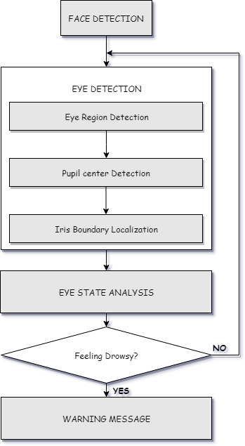

Figure 1: Block Diagram

### System Design

#### Use case diagram

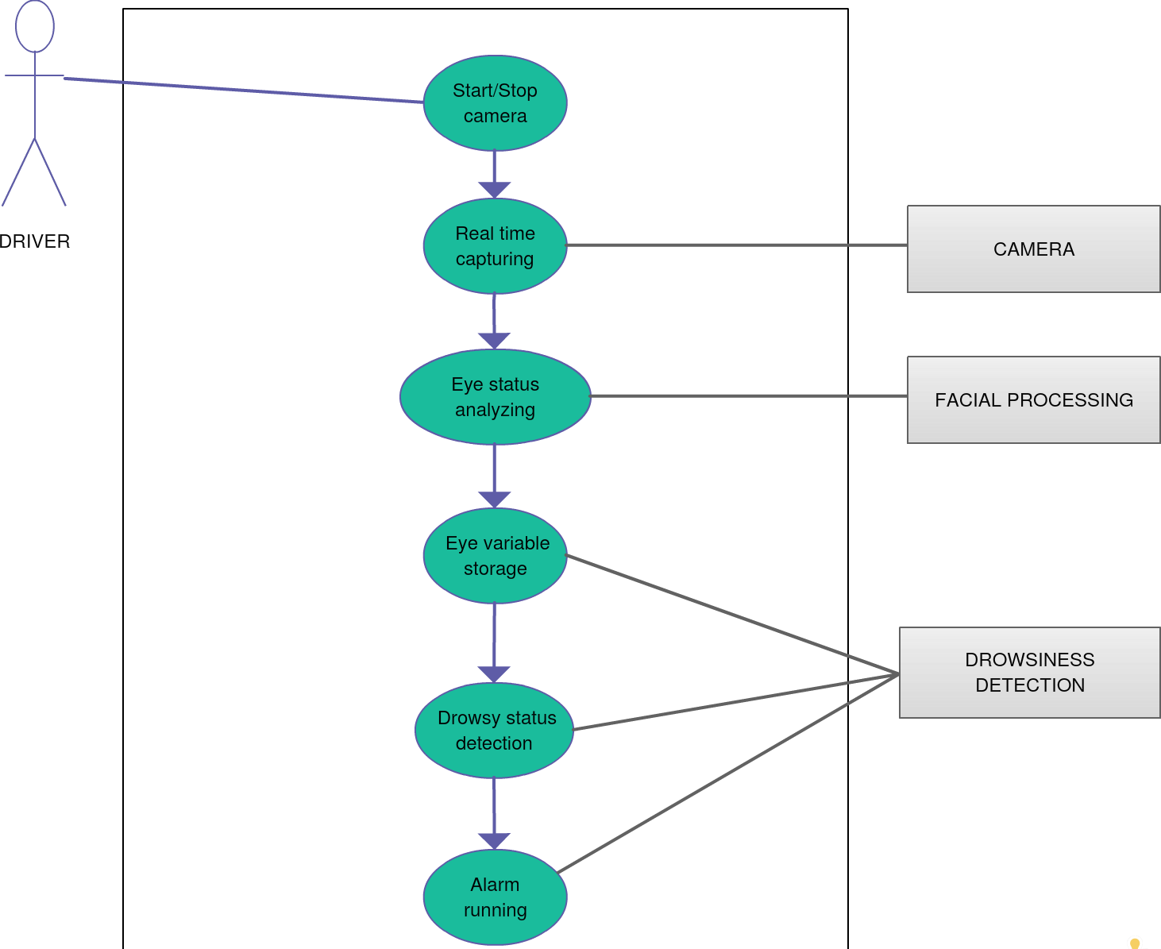

Figure 2

#### 5.2 Activity diagram

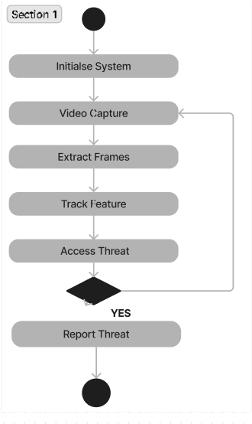

Figure 3

**Implementation**

* Importing modules

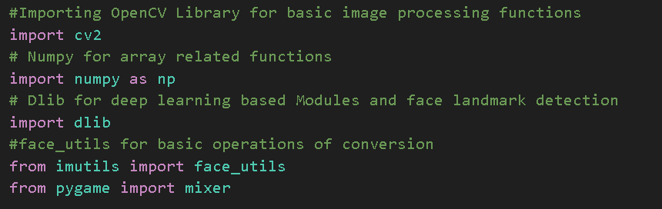

* In our program we used Dlib, a pre-trained program trained on the to detect human faces using the pre-defined 68 landmarks.

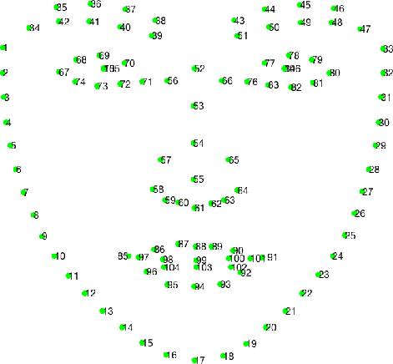

Landmarked Image of a person by Dlib

* After passing our video feed to the dlib frame by frame, we are able to detect left eye and right eye features of the face.

Now, we drew contours around it using OpenCV.

* Using Scipy’s Euclidean function, we calculated sum of both eyes’ aspect ratio which is the sum of 2 distinct vertical distances between the eyelids divided by its horizontal distance.
* Now we check if the aspect ratio value is less than 0.25 (0.25 was chosen as a base case after some tests). If it is less an alarm is sounded and user is warned.

* The landmarks for Eye’s are

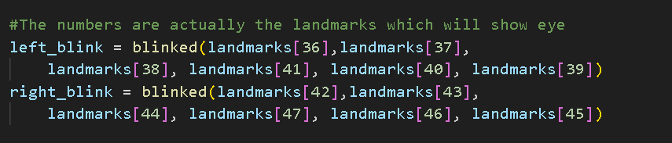

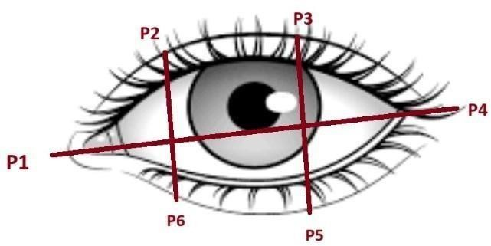

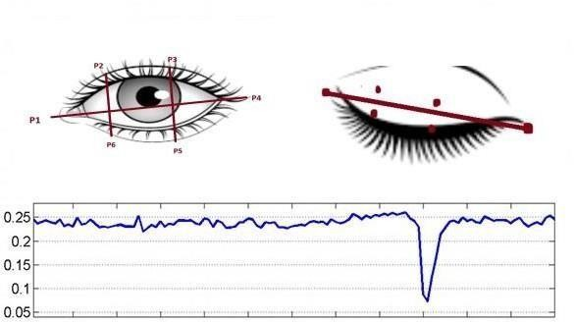

**Landmarks eye on**

### System Testing

#### 7.1 Test Cases and Test Results

|  |  |  |  |
| --- | --- | --- | --- |
| Test | Test Condition | System Behavior | Expected Result |
| ID |
| T01 | Straight Face, Good Light, With Glasses | Non Drowsy | Non Drowsy |
| T02 | Tilted Face, Good Light, No Glasses | Drowsy | Drowsy |
| T03 | Tilted Face, Good Light, With Glasses | Drowsy | Drowsy |

**Note: Testing is performed manually**

### Outputs

#### 8.1 Face landmarks 8.2 Non-drowsy Person

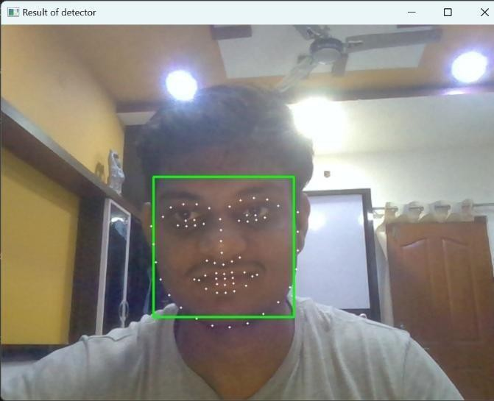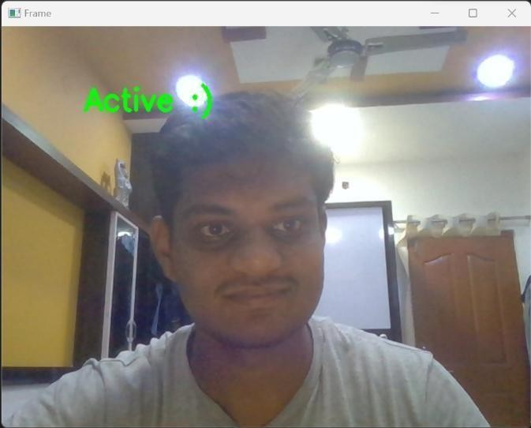

**8.3 Drowsy Person: 8.4 Sleeping Person:**

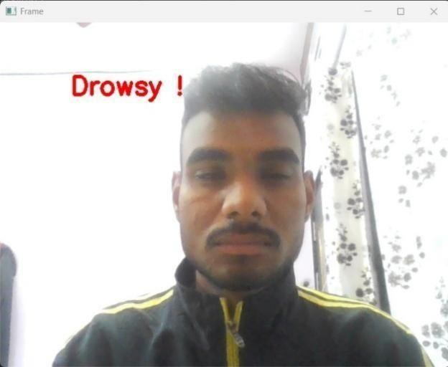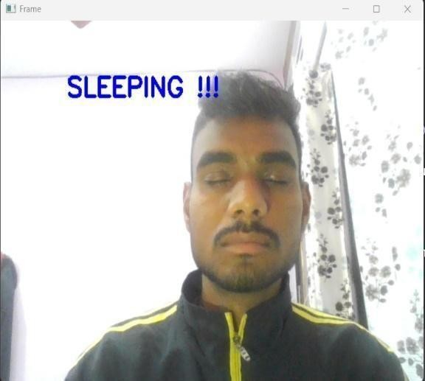

**Drowsy state Sleeping state**

### Conclusion and Future Scope

#### Conclusion

Driver Drowsiness Detection System, I'd say that the implementation of this system marks a significant stride towards mitigating one of the leading causes of road accidents—driver fatigue. By employing advanced technologies such as computer vision and machine learning, we've successfully developed a real-time solution capable of identifying signs of drowsiness in drivers.

Our approach, utilizing facial landmark detection and eye-tracking algorithms, coupled with machine learning classifiers, has proven effective through rigorous testing. The successful integration of Python, along with powerful libraries like OpenCV,Scipy,Dlib and imutils, has not only streamlined the development process but also ensured the system's adaptability and scalability for potential future upgrades.

It's important to emphasize that while our Driver Drowsiness Detection System represents a promising step forward, it should be seen as a supplementary safety measure rather than a replacement for responsible driving habits. Encouraging regular breaks, promoting awareness of the dangers of driving while fatigued, and fostering a culture of safety remain crucial components of overall road safety.

#### Future Scope

The model can be improved incrementally by using other parameters like blink rate, yawning, state of the car, etc. If all these parameters are used it can improve the accuracy by a lot.

Same model and techniques can be used for various other uses like Netflix and other streaming services can detect when the user is asleep and stop the video accordingly. It can also be used in application that prevents user from sleeping

### References

* + - <https://www.python.org/>
    - <https://opencv.org/>
    - https://elevenlabs.io/